Keywords: Bilderberg, Fed, Chicago,

Mr. Strong And The Birth Of The Fed

From http://elainemeinelsupkis.typepad.com/money_matters/2008/07/mr-strong-and-t.html

July 5, 2008
Elaine Meinel Supkis
It is with rising irritation I read all sorts of editorials and explanations about what is going on as the Imperial Banking System set up first, by England then by the US, crash and burn. We cannot understand the present unless we understand the past! And to do this, we should not look at present histories but read the past directly. So I went in search of speeches by the first Federal Reserve chief who was actually the head of the Federal Reserve Bank of New York: Benjamin Strong. I found it nearly impossible to get his speeches so I did one lower step: newspaper stories from his reign. This opens many interesting doors, by the way.
September 18, 1913
Copyright © The New York Times
[Bankers] Want Regiment For Wall Street Guard
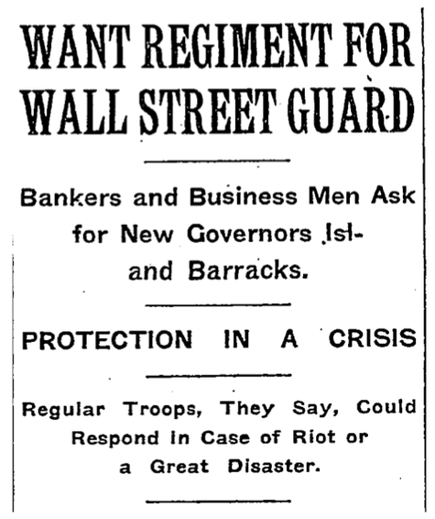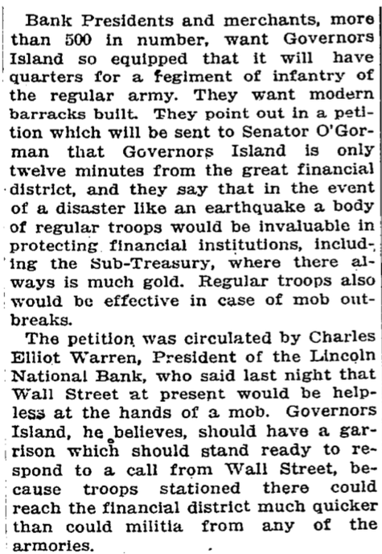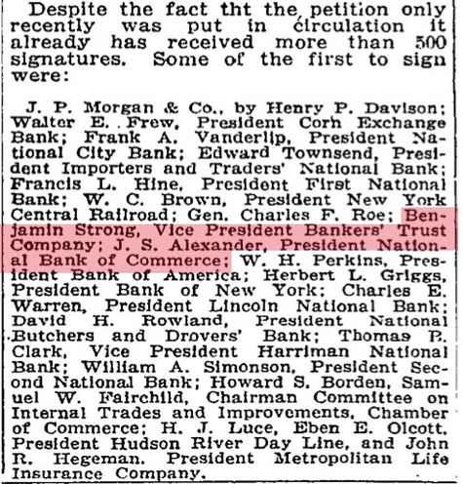
What is this? Where did this come from? It is amusing, horrifying and strange! This news is only three months before the Federal Reserve was passed by a ghost Congress and suddenly signed by President Wilson. This is a scant 3 years after the Jekyll Island conspirators met. Always, whenever I chase after interesting names, I fall into rabbit holes. This is one such hole. I was looking for speeches by the First putative Fed Chief. Back in the beginning, there was no such person. There was the main branch of the Fed system which was and still is the Bank of New York.
It is very difficult to track the trail of the elusive Golden Hart if one relies on only modern tales or books. When I sail merrily about the web, seeking information is like talking to the Delphic Oracle. She will breathe the magic vapors and then give cynical, dark answers. So asking this Dame the right questions matters a lot. I have found over the years, if I include various interesting dates, I get neat old news paper articles that more often than not, give new insights and information. This is a classic case. I was asking about Benjamin Strong, the first powerhouse of the Federal Reserve and got the above story. Let's examine this!
Jan 1, 1913: GARMENT WORKERS IN RIOTS; BESIEGE NEW YORK FACTORIES
Strike Marked by Violence and Airests--Police Called to Drive Workers from Pire Escapes of Shop.
April 8, 1913,: TROOPS UNDER ARMS IN BUFFALO STRIKE; Street Cars Riddled with Stones When Strikebreakers Try to Operate Them.
BUFFALO, April 7. -- Cars were showered with stones, several persons injured and numerous small riots occurred to-night when the International Street Railway Company attempted to operate its cars with 700 strikebreakers.
"Student Strikers Wreck Lunchroom" (New York Times, May 7, 1913) Hahaha, students in a Brooklyn high school claimed they were tired of singing 'Stodgy old songs' and wanted to sing, 'Snooky-ookums' instead.
In Paris, there was the famous Stravinsky/Nijinsky 'Rite of Spring' riot.
Even without knowing it directly, the 'center' was failing. Something was going to collapse, perhaps, many things were going to collapse. The ruling elites were extremely nervous. A number of spectacular assassination successes and attempts troubled the ancient ruling elites of Europe and the much newer ruling elites in America. Revolutionary change was sweeping through the arts, through the schools and through the political halls, the beer halls, change was, unlike today, truly in the air. The battle over power and control was a rising tide that even leeched into Brooklyn High Schools. There was real fear in the seats of power. The Federal Reserve was launched in an effort to contain and control all of this. But even within the Federal Reserve, control was being contested.
But first, we have to understand the relationship of gold and the NY Fed. It is a key to what happened from 1913-1933:
33 Liberty Street
The Federal Reserve Bank of New York maintains a vault that lies 86 feet (26 m) below sea level, resting on Manhattan bedrock. By 1927, the vault contained ten percent of the world's official gold reserves. Currently, it is reputedly the largest gold repository in the world (though this cannot be confirmed as Swiss Banks do not report their gold stocks) and holds approximately 5,000 metric tons of gold bullion ($160 billion as of March, 2008), more than Fort Knox. The gold is owned by many foreign nations, central banks and international organizations. The Federal Reserve Bank does not own the gold but serves as guardian of the precious metal, which it "protects" at no charge as a gesture of good will to other nations. Free tours of the vault are available to the public.
Moving Gold Bars from the Bank's Vault
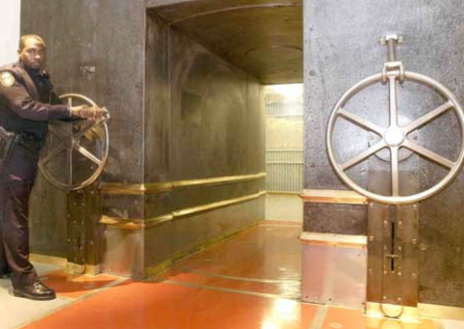
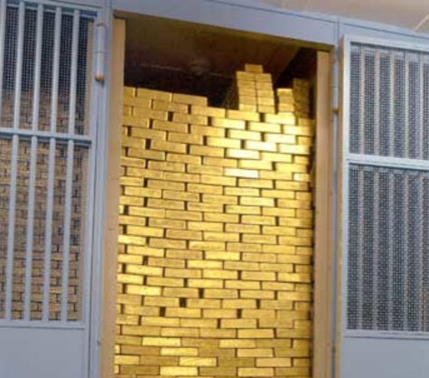
Everyone talks about Fort Knox but no one talks about the Fed Reserve vaults in New York City where INTERNATIONAL gold is stored, not US Treasury gold. The business of being a 'guardian' is based on one thing and one thing only: NYC can't be invaded and the gold, stolen. Why was this?
Germany, when Bismark invaded in the 19th century, took a great deal of France's gold! The British were certain no one could take their gold hoard or see if it was faulty...note that it wasn't investigated for purity until recently and found to be wanting, by the way. Since the French Revolution, the French have been very much gold-mad and desirous of some fashion for hiding gold from invaders while controlling this gold. The near-taking of Paris a second time by the Germans spooked the French who squirreled away all this shiny metal in NY.
The Gold Vault of the FED of New York
The gold bullion in the Federal Reserve Bank of New York's vault is part of the monetary reserves of 36 foreign governments, central banks, and official international organizations around the world. It is stored in 122 separate compartments in the main and auxiliary vaults. It is largely a relic of an era when the gold standard and gold exchange standard were used to establish the relative values of national currencies, and gold itself was used to meet international payments.
The gold stored at the Federal Reserve Bank of New York is secured in a most unusual vault. It rests on the bedrock of Manhattan Island which is very adequate to support the weight of the vault, its door and the gold inside. It is located 80 feet below street level and 50 feet below sea level.
In mid- 2005, the Federal Reserve Bank's vault contained roughly 266 million troy ounces of gold representing 25 to 30 percent of the world's official monetary gold reserves. At the time, the vault gold's was $9.5 billion at the official U.S. Government price of $42.2222 per troy ounce, or about $90 billion at the market price of $400 an ounce. At the current official U.S. Government price, one of the vault's gold bars (approximately 27.4 pounds) is valued at about $17,000. At a $400 market price, the same bar is worth about $160,000.
The governments and official international organizations that store their gold in this place have total confidence in its safety, find very convenient all the services that the Bank offers to them and think that its location is unequalled for being in the center of one of the world’s leading financial capitals.
Confidence: It results from the Bank's being part of the Federal Reserve System (the nation's central bank and an independent governmental entity). The political stability and economic strength of the United States, as well as the physical security provided by the Bank's vault, also are important factors.
Convenience: It comes from the fact that the Federal Reserve Bank of New York, in addition to handling foreign financial transactions for the U.S. Department of the Treasury and the Federal Reserve System, executes many other financial transactions in the United States for foreign central banks.
Location: The gold deposited in the trade and financial capital of the world's largest economy enables countries to engage in transactions of all sizes easily, quickly, and inexpensively.
The construction of the building was completed in 1923 and since then it has maintained its continuous operations. Foreign-owned gold valued at $26 million (at the official price at that time of $20.67 a troy ounce) was on deposit with the Federal Reserve Bank of New York when the main vault was opened in September 1924. Holdings rose to about $458 million by the end of 1931, then fell sharply during the Great Depression. The economic problems of the United States, a slump in world trade, the lack of confidence in the international monetary system, and a desire to provide a boost to their troubled economies prompted many nations to recall their gold. By 1935, foreign gold deposits had fallen to about $9 million, even though the official price of gold had been raised to $35 a troy ounce by the Gold Reserve Act of 1934.
The threat of war in Europe reversed the trend of Depression-era withdrawals and brought a virtual flood of gold to the New York Fed for safekeeping. More than $1 billion poured in between 1936 and 1939, when Germany invaded Poland. By the end of the war in 1945, foreign gold reserves stored at the Federal Reserve Bank had risen to more than $4 billion.
As nations with trade surpluses with the United States accumulated more dollars than they needed, they often exchanged their dollars for gold. The gold coffers of these nations in the New York Fed's basement bulged. From 1947 to 1971, the year the United States suspended convertibility of dollars into gold for foreign governments, about $10 billion more was deposited in the vault, bringing the total value of gold holdings stored at the New York Fed to $14 billion at the official price of $42.2222. Since 1972, there has been a gradual, but steady, net withdrawal of gold from the vault.
Several things here: the storage of gold back then was a matter of security. Also, the need to use gold in foreign trade deals is probably the most important function of gold. The United States had no problem with using gold reserves held by or protected by the US as leverage in international trade. By the way, the dynamics of the period from 1927-1937, this decade saw France in particular, remove gold rapidly from the bank vaults in Manhattan and transfer of this gold to Paris and the new safety vaults built there. When Hitler began to overrun Europe, this process reversed. Also, all the private gold held by the rich in Europe flowed to New York in rising fear of yet another war. Switzerland was not considered a safe haven, especially for Jewish people wishing to protect their wealth in the face of one of the world's nastier examples of looting and ethnic cleansing which was barely begun in 1937.
Here are two headlines from the past showing this ebb and flow of gold in US banks:
GAIN ON GOLD HELD BY RESERVE BANKS; New York Leads, with Increase of $3,800,000 -- System's Paid-In Capital About $53,500,000.
May 1915: The Federal Reserve Board's weekly summary indicates a substantial gain in the total reserves and in the gold reserves of the Federal Reserve banks. The only banks which fail to show increased gold reserves are San Francisco, Richmond, and Chicago.
ENGLAND DRAWS EARMARKED GOLD HELD IN NEW YORK
April 26, 19333:
Great Britain today began the repatriation of the $250,000,000 or more of earmarked gold which she holds here. The federal reserve bank reported that $2,199,900 gold had been taken out of earmark and that $2,199,500 had been shipped to England under license.
In all of this, we nearly forget about Benjamin Strong and the birth of the Federal Reserve. At the beginning, there were just the various banks of various regions. None were in total control but thanks to the gold reserves held in Manhattan on behalf of foreign traders and governments, the Bank of New York had primacy within the Federal Reserve. Very early one, they were concerned about revolutionaries storming this gold vault and stealing all the gold. So they petitioned the Federal Government to place US military nearby so these troops could be used to attack the US civilian public.
I found the article about the need to station Federal troops on Governor's Island because Mr. Strong was one of the petitioners hoping Uncle Sam would put Federal troops in a convenient spot whereby they could come into lower Manhattan and shoot anyone storming Wall Street. Note that JP Morgan tops this list of rich bankers wishing for Federal military support. Of course, this was feared by the Southerners who had the Posse Comitas Act passed to prevent Federal troops protecting former slaves from the KKK. So despite the fear of revolutionaries in NYC, this didn't happen. The troops were not moved to a convenient island nearby where they could invade and put down insurrections in Manhattan.
By the way, this has been solved via the nifty act of having invaders attack Wall Street on 9/11. Now, we see private mercenaries in the pay of Homeland Security invading anyplace they wish. But back then, paranoia in other parts of the US prevented this solution. When the new central bank complex was launched, Mr. Strong, not J.P. Morgan or the other very rich robber barons ran it. Why is this?
New York Times October 6, 1914
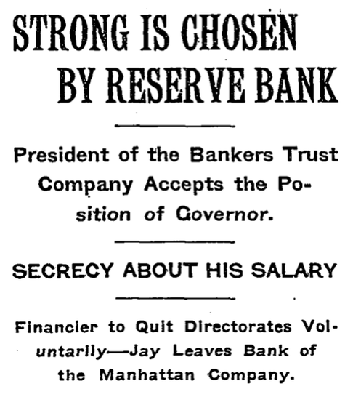
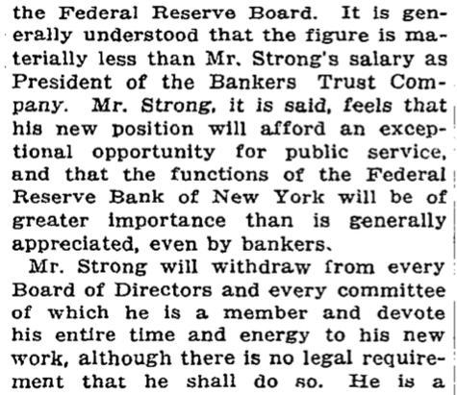
It turned out the pay was much less than the pay for running his bank. Mr. Strong was asked to make a SACRIFICE on behalf of the other bankers like J.P. Morgan who would shoot himself in the head rather than sacrifice a penny of his own wealth. Here is a key sentence in the 1913 story:
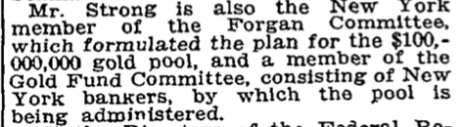
He was already in charge of dealing with creating and running THE GOLD POOL for international trade and banking! This was of greatest importance. The US bankers in New York understood that in order to contain rivals overseas, the US needed the same sort of systems the other international traders used. But this was anathema to the greater mass of domestic suppliers and businesses. Namely, Main Street, USA. Mr. Strong was seen as a good person to use to keep the US public asleep while he would work insidiously on behalf of all the international markets and foreign bankers! He was the Intermediary. The Bridge.
I am going to skip over for right now [but not for long!] the business of WWI, the huge debts owed by British and French governments, Germany's amazing hyperinflation and other international matters to talk about Mr. Strong's last works. Since I could find no speeches by him, I am relying on old Time Magazine articles here. Like this one from one year before the whole thing came crashing down around our heads:
International Bankers
Tiime Magazine, Jul. 11, 1927
Chiefs of the national banks of England, France and Germany debarked at Manhattan last week for their regular summer conference and discussion of world economics with their good friend, Benjamin Strong, Governor of the Federal Reserve Bank of New York. All had been in the U. S. before, but severally. All had met before, but in Europe, where heretofore Governor Strong has spent his summers visiting with them. These comrades in finance, these truly international bankers, were:
Charles Rist, Deputy Governor of the Banque de France (Emile Moreau is Governor), a close-mouthed man, who was of the four least known to U. S. newsgatherers. Few realized that he had been professor of law in the Faculté de Droit de Paris; that he was an intimate of Premier Raymond Poincare of France; that he was an intimate of onetime (1917 & 1925) French Premiers Paul Painlevé and (1924-25 & 1926) Edouard Herriot, with whom in 1921 he helped organize the now moribund Ligue de la Republique to fight Alexandra Millerand's Bloc National and establish a policy of democratic post-War reconstruction. M. Rist has been Deputy Governor of the Banque de France for only the past year. He is one of Europe's most profound economists.
Dr. Hjalmar Schacht, President of the German Reichsbank, with a mind as clear-thinking as a calculating machine, is one of the constructive geniuses of post-War Germany. Born in 1877 he was a partner in the Darmstadter-und-National bank until 1923, worked with the Reich Currency Commission that set up the present gold mark standard in Germany, cooperated with the (Charles Gates) Dawes Committee on German reparations. He has been president of the Reichsbank since 1924. He is a stern man to deal with, imperturbable and ruthless in carrying out a fiscal program. Only seven weeks ago, when German speculators were running wild, he passed put instructions that loans to Berlin stock market operators be instantly reduced by onefourth. There was panic on the Berlin Bourse (TIME, May-23).
Montagu Collet Norman, Governor of the Bank of England, is most picturesque of the four. Reared in that fin-de-siècle British atmosphere that supplied Margot, Viscountess Oxford & Asquith with long, pendent earrings, Oscar O'Flahertie Wills Wilde with a sunflower boutonnière and Winston S. Churchill with a paunch, Montagu Collet Norman affects a soft felt hat, bow necktie and a superbly pugnacious goatee. Like his contemporaneous compatriots his wit is keen, his thinking sharp, his knowledge authoritative. Born in 1871, he has been Governor of the Bank of England since 1920.
This was the pre-Bilderberger meetings. The head of the NY branch of the Federal Reserve was very anxious to hobnob with and mesh with the other older empires. They, in turn, would insure the US would have a free hand in places like Central America or the Caribbean Ocean. Do note how Schacht of Germany's banking system restarted the gold system which collapsed during WWI. First, it became a 'renten mark' which was based on the value of all landholdings in Germany. Then it reverted to the gold standard and became the Reichsmark. In 1927, the NY bank head is busy as a bee, conspiring with foreign powers on behalf of no one but this buddies in NYC. Like J.P. Morgan, for an obvious example.
Time Magazine, 1927:
Benjamin Strong, Governor of the New York Federal Reserve Bank, is farther from the U. S. Government than his three banker visitors are from their governments. Their banks are the fiscal agents for England, France and Germany. In the U. S. the Treasury Department is the Government's money agent. In many cases and for many reasons it delegates its authority as agent to Federal Reserve banks, but those Federal Reserve banks are secondary, as it were, sub-agents of the Government. None the less Governor Strong as head of the New York Federal Reserve Bank wields financial authority fully comparable to that swung by the Messrs. Norman, Rist and Schacht, for it is to Manhattan banks that foreign banks turn for credit, and over Manhattan banks hovers Governor Strong's influence. Governor
See how Strong operated? Was he forced to tell the President or Congress what he was doing? No! Also, notice how this early article written just before the Great Depression, the Fed assumes the TREASURY is in charge of 'money', not the Federal Reserve! The gold at Fort Knox was in the hands of the Treasury, not the Federal Reserve. The Fed was a SUB-AGENT of the government, not a primary agent of controls. The reporter here also correctly notes that the true power of Strong surpassed the legal definitions set to restrict the powers of the brand new central bank.
From 1927:
The matters that these four international bankers will discuss were, of course, unknown to newsgatherers last week.
*snip*
Knowing the routes of commerce is of no less importance to them than is the neighborhood route to the morning's milkman. And the best way to learn, they have wisely decided, is viva voce, by friendly conversations.
Notice how the reporter notes that this is all very SECRET. The supposed need to discuss what they plan to do to the rest of humanity had to be done in total secrecy! Through 'friendly' conversations. Which, a mere 10 years later, were very unfriendly conversations carried on via shooting guns. The Time Magazine reporter, being a dutiful person who didn't want to be fired and blacklisted, told his readers this secret sort of connivance was good for us all. Friendly, pleasant ways of dealing with difficulties. Yes, indeed.
But Mr. Strong was dying. This made him physically weak. The battle over how US finances would operate heated up even as his ulcerous health declined:
Chicago v. New York
Time Magazine, Jul. 30, 1928
In Washington, a man named Roy A. Young presides day by day over the Federal Reserve Board, central authority of the twelve regional banks. In Chicago, Minneapolis, Atlanta, sit Governors with as much authority as clothes the Governor of New York's bank. But when Benjamin Strong, lean, nervous, enters the doors of the Bank of England, or when Benjamin Strong, ill, receives the foreign chiefs in Manhattan, no Wall Streeter thinks of the quiet, unostentatious figure in the Treasury building's spacious offices. And certainly no Streeter thinks of such an untraveled, provincial person as a banker in Minneapolis, or Atlanta, or Chicago might be supposed to be.
So compelling was the prestige of cosmopolitan Gov. Strong that it seemed almost presumptuous when Chicago bankers ventured, last fall, to' challenge the wisdom of his international money-juggling. If wise Gov. Strong, fresh from a meeting of master minds, thought Chicago should reduce its rediscount rate from 4 to 3½% to aid his European comrades in finance, only bad manners or sheer contrariness could explain Chicago's dissent. Gov. Strong was cast for the hero's role in the drama of U. S. money. Obviously, all that remained for Chicago was to be the juvenile or the villain.
Last week, Gov. Strong was again in Europe. And his Manhattan supporters noted with alarm that Chicago was showing distinct signs of insubordination, was even pretending to take the lead in the intricate business of money-juggling. Boldly, the Chicago Reserve Bank recalled its warnings of last fall, pointed to diminishing credit reserves and wild speculation, jumped its rediscount rate to 5% (TIME, July 23). Manhattan, accustomed to lead, was forced to follow. Chicago's press openly flayed the absent Gov. Strong; screechingly demanded his resignation.
Puzzled, irritated, New York bankers asked questions. Who gave provincial Chicago the right to criticize internationally-minded Manhattan and its Gov. Strong? In New York papers, an anonymous banker charged the regional bankers suffered "delusions of grandeur." And, if it came to that, who were these Chicagoans, anyway?
So, there was a conflict between Chicago and NY? Aside from the Yankees versus the Chicago White Sox, of course. Both Wall Street and European bankers wanted the US to have low interest rates. Preferably below the rate of inflation. I really don't know what to make about all of this right now. It will be fruitful to pursue this a bit further. But already, there are too many distractions! Strong was working on behalf of international finance and Chicago was focused on the Heartlands. This is always the case. Devotees of Funny Money ™ abound on Wall Street. Just like they ignore or mock the Midwest and call it today, 'the Rust Belt', even back then, they didn't care much if Main Street or the manufacturing base in the midlands collapsed. They wanted money to play speculative games! Money that is 'leverage' not 'profit'.
Mr. Strong was only 55 years old when he collapsed.
Death of Strong
Time Magazine, Oct. 29, 1928
Columns of newsprint recorded his achievements, mourned him. Editorial writers lauded him, decried his untimely end at 55. Among all these encomiums there was one dissenting voice. Said the Barron-bereaved Wall Street Journal, editorially: "His services were of the highest value and conditions today might have been different if his health had permitted undivided attention to his office for the past three months."
Bitter words to a dead man. More bitter had been the Journal's polemics of the past six months. For many an analyst believed it was the Strong policy of easy money which led to the stock market's frenzied speculation. And many a bull, in Manhattan and in Chicago, damned bitterly the Federal Reserve Bank's efforts to undo, by raising the rediscount rate, the mischief it had done. Most bullish of all bulls is the Journal. Most hateful, therefore, is the present high rediscount rate.
Strong died and interest rates shot upwards. The Fed's banks decided to remove the punch bowl because NY was punch-drunk. Despite this, the stock market frenzy continued for one year. As we see today, raising rates to kill a bubble is fatal. Instead of preventing the bubble from being launched, this post-debacle methodology always causes a violent reaction. Just as feeding a bubble only makes it much, much worse. Understanding that continuous price hikes in anything is inflation is important! Of course, this is ignored since we WANT price hikes...in property, art work, gold, anything nifty we possess and then can sell for a profit. When it hits things we need to survive, then we suffer.
Stopping this sort of inflation via higher interest rates causes tremendous pain for everyone just as hyperinflation kills everyone in the long run. To avoid both requires wisdom. And anyone foreign that is consulted would obviously advise choices and solutions that benefit THEM, not one's self.
July, 2008: Fed's Bullard says bank's credibility on line
(Reuters) - The Federal Reserve's use of core inflation measures is harming its credibility, the new president of the St. Louis Fed wrote in an editorial released on Thursday.
James Bullard, who took over from William Poole in April, said focusing on inflation indices that exclude food and energy work well when those prices are rising at rates similar to those of other prices, "but that is not what is happening today.
"It is hurting Fed credibility to say that we are trying to keep inflation low and stable, but at the same time we are not counting some of the prices that are going up at the most rapid pace," Bullard wrote in the bank's magazine, "The Regional Economist."
The deadly 'inflation' statistics the Fed uses to deceive us is destroying our economy. A refusal to look at reality means lending money at below the real rate of inflation and this, in turn, disorders world trade, weakens industries and misallocates finances. Inflation will rage if it is ignored. And inflation of necessities is the most vital and dangerous of them all.
Bush's final G-8 appearance starts Sunday in Tokyo
President Bush will continue his formal exit from the world stage when he arrives in Japan on Sunday for his final annual meeting with leaders from seven of the world's other top economic powers.
With the northern Japanese island of Hokkaido as a backdrop, Bush and the other heads of the so-called "Group of Eight" nations will wrestle over what to do about the unsettled international economy, high oil prices and climate change.
But with the G-8 leadership in flux and several of its members crippled politically by their unpopularity at home, questions abound about what they can accomplish during their three days together. Attending will be leaders from the United States, United Kingdom, France, Germany, Italy, Canada, Japan and Russia. The first seven invited Russia to join the annual affairs in the 1990s to encourage its turn to democracy.
"We used to live in a world where the seven, then eight, had so much power and wealth it (the G-8) could somehow steer the agenda," said Carlos Pascual, the director of foreign policy studies for the Brookings Institution, a center-left research center. "We live in a very, very different world, and the headline out of this meeting, I think, is the time of the G-8 as the center of global power-brokering is over."
The old European empires of Russia, England, Germany and France join the new ones in America and Japan to control world banking? HAHAHA. It failed in the past and will fail today. The inner tensions of these trade and banking RIVALS are of course, at cross purposes. And on top of this, the US is going bankrupt. Even the goofiest banker in NY 100 yeas ago wasn't so dumb as to go BANKRUPT! This was anathema to them. So here we are, limping about the world stage, secretly or in the open, trying to fix our messes by conspiring with our RIVALS. And this is the key: there are no 'alliances' in Real Politik. There are conflicting purposes, dreams, desire for revenge, histories and levels of wealth and power. Anyone too stupid to see this obvious fact should be sent home to suck on a lollipop, not negotiate even more bad deals.

July 05, 2008 | Permalink

TrackBack
TrackBack URL for this entry:
http://www.typepad.com/t/trackback/763647/30917858
Listed below are links to weblogs that reference Mr. Strong And The Birth Of The Fed:

Comments
Of course meetings about the looting of the middle-class peasantry via debt are secret, silly!
http://cryptome.org/treas070108.htm
DEPARTMENT OF THE TREASURY
Departmental Offices; Debt Management Advisory Committee Meeting
Notice is hereby given, pursuant to 5 U.S.C. App. 2, section
10(a)(2), that a meeting will be held at the Hay-Adams Hotel, 16th
Street and Pennsylvania Avenue, NW., Washington, DC, on July 29, 2008
at 10:30 a.m. of the following debt management advisory committee:
Treasury Borrowing Advisory Committee of the Securities Industry
and Financial Markets Association.
....
The public interest requires
that such meetings be closed to the public because the Treasury
Department requires frank and full advice from representatives of the
financial community prior to making its final decisions on major
financing operations. Historically, this advice has been offered by
debt management advisory committees established by the several major
segments of the financial community. When so utilized, such a committee
is recognized to be an advisory committee under 5 U.S.C. App. 2,
section 3.
Posted by: GK | July 05, 2008 at 08:11 PM
Yeah, these stupid conspirators NEVER lie to each other. ....HAHAHA.
They want to have a serious discussion of the peasantry. How to trick them. Who gets stuck with paying the bills of the gentry [hint: ain't gonna be the damn gentry!]. No, they don't even want Ron Paul to pull to the curb and try walking in the door.
Posted by: Elaine Meinel Supkis | July 05, 2008 at 08:47 PM

